CS 255 Business Requirements Document Template

Complete this template by replacing the bracketed text with the relevant information.

This template lays out all the different sections that you need to complete for Project One. Each section has guiding questions to prompt your thinking. These questions are meant to guide your initial responses to each area. You are encouraged to go beyond these questions using what you have learned in your readings. You will need to continually reference the interview transcript as you work to make sure that you are addressing your client’s needs. There is no required length for the final document. Instead, the goal is to complete each section based on your client’s needs.

Tip: You should respond in a bulleted list for each section. This will make your thoughts easier to reference when you move into the design phase for Project Two. One starter bullet has been provided for you in each section, but you will need to add more.

System Components and Design

Purpose
What is the purpose of this project? Who is the client and what do they want their system to be able to do?
- The purpose of this proposed system is to design a web-based platform for DriverPass that helps customers prepare for the Department of Motor Vehicles (DMV) written exam and manage driving lesson scheduling through a centralized system. This system is intended to improve access to training materials, streamline scheduling, and support overall business operations (Southern New Hampshire University, n.d.; Dennis et al., 2012).
- The client is DriverPass, a company that provides driver training services and wants an online system that allows customers to study for the DMV exam and schedule driving lessons (Southern New Hampshire University, n.d.).
- The system is expected to support customer account creation, access to training materials, practice testing, and lesson scheduling, while also allowing staff to manage reservations and customer records, which reflects the required system functionality identified during analysis (Dennis et al., 2012).
- The system will replace inefficient manual or disconnected processes with a centralized web-based solution to improve accuracy, organization, and user experience (Southern New Hampshire University, n.d.).
System Background
What does DriverPass want the system to do? What is the problem they want to fix? What are the different components needed for this system?
- DriverPass wants a web-based system that allows customers to prepare for the DMV written exam by accessing training materials that reflect current DMV rules, regulations, and test content. The system must stay aligned with DMV updates so that customers are studying accurate and relevant information for their exams (Southern New Hampshire University, n.d.).
- The system must support customer access to online practice exams that simulate the DMV written test. These practice tests allow customers to measure their readiness and improve their understanding before taking the official exam.
- The system must allow customers to purchase specific driving packages that include a defined number of driving lessons. These packages are a core part of the business model and must be tracked within the system so that lesson usage, remaining sessions, and customer progress are accurately maintained (Southern New Hampshire University, n.d.).
- The system must allow customers to schedule, reschedule, and cancel driving lessons based on instructor and vehicle availability. This process must be managed through the system to ensure accurate scheduling and to prevent conflicts or double bookings.
- The system must define user-level access requirements so that each type of user can only perform actions appropriate to their role. Customers must be able to create accounts, access training materials, take practice tests, and manage their lesson schedules. The secretary must be able to manage reservations and customer records. The Information Technology (IT) officer must be able to maintain the system, manage accounts, and reset passwords. The system owner must be able to access reports and monitor overall business operations (Southern New Hampshire University, n.d.).
- The system must generate reports that allow the system owner to review customer activity, lesson scheduling data, and overall business performance. These reports support decision-making and help track how the system is being used.
- The primary problem DriverPass wants to fix is the lack of a centralized system to manage customer training, scheduling, and business operations. Without a centralized system, scheduling can become inconsistent, records may be inaccurate, and staff must rely on inefficient or manual processes.
- Another problem is the lack of integration with up-to-date DMV information. DriverPass needs a system that ensures all training content reflects current DMV standards so customers are properly prepared for their exams.
- The system must include a customer-facing component that allows users to create accounts, log in securely, access training materials, complete practice tests, and manage their lesson schedules.
- The system must include an administrative component that allows staff to manage customer data, reservations, and system operations. This ensures that staff can support customers and maintain system accuracy.
- The system must include a centralized database component to store customer accounts, lesson schedules, instructor and vehicle assignments, package information, and training progress. This ensures that all system data is consistent and accessible to authorized users (Dennis et al., 2012).
- The system must include scheduling logic that verifies instructor and vehicle availability before confirming a lesson. This ensures accurate scheduling and directly supports the system’s scheduling workflow and validation process.
- Defining the system background with detailed processes and components ensures that the final system design fully addresses business needs and operational challenges and supports accurate system development (Dennis et al., 2012).

Objectives and Goals
What should this system be able to do when it is completed? What measurable tasks need to be included in the system design to achieve this?

Goals
- The system shall provide customers with access to DMV-aligned training materials and practice exams to support preparation for the written driving test (Southern New Hampshire University, n.d.).
- The system shall allow customers to create accounts, log in securely, and manage their personal information within the system.
- The system shall allow customers to purchase driving packages that include a defined number of lessons and track their remaining sessions.
- The system shall allow customers to schedule, reschedule, and cancel driving lessons based on instructor and vehicle availability.
- The system shall allow staff, including the secretary, to manage reservations and update customer records as needed.
- The system shall allow the IT officer to manage user accounts, reset passwords, and maintain system functionality.
- The system shall generate reports for the system owner that include customer activity, lesson scheduling data, and overall system usage.
- The system shall maintain a centralized database that stores all customer, scheduling, training, and package information.
Objectives
- The system should support efficient task completion for users interacting with scheduling and training features.
- The system should maintain accurate scheduling data with no overlapping lesson bookings by verifying instructor and vehicle availability before confirming reservations.
- The system should ensure that training materials and practice exams reflect current DMV requirements by updating content whenever new information becomes available (Southern New Hampshire University, n.d.).
- The system should maintain data accuracy across all user interactions so that customer records, lesson schedules, and progress tracking remain consistent and reliable.
- The system should support multiple users accessing the system at the same time without causing significant delays or system errors.
- The system should reduce scheduling errors and manual processing by using automated system checks and centralized data management.
- The system should provide reliable access to reports so the system owner can monitor performance and make informed business decisions.
- Objectives define how system success is measured by showing whether required tasks are completed efficiently, accurately, and consistently across all system functions (Dennis et al., 2012).

Requirements

Nonfunctional Requirements
In this section, you will detail the different nonfunctional requirements for the DriverPass system. You will need to think about the different things that the system needs to function properly.

Performance Requirements
What environments (web-based, application, etc.) does this system need to run in? How fast should the system run? How often should the system be updated?

- The system shall operate as a web-based system accessible over the internet. This ensures centralized performance and allows all users to interact with the same system environment without requiring local installation (Southern New Hampshire University, n.d.).
- The system shall load primary system pages, such as login, account access, scheduling, and training materials, within approximately 2 to 4 seconds under normal operating conditions. This response time supports efficient user interaction and reduces delays when completing tasks.
- The system shall process system requests, including data retrieval and data updates, within a few seconds under normal usage conditions. This ensures that users receive timely feedback when interacting with the system.
- The system shall process scheduling-related operations in real time or near real time so that availability data remains accurate and consistent. This is important because scheduling is a core function of the system and relies on up-to-date information.
- The system shall support concurrent access by multiple users without significant performance degradation. Customers, the secretary, and administrative roles may use the system at the same time, so performance must remain stable under shared use.
- The system shall maintain consistent performance during peak usage periods, such as evenings and weekends, when user activity is expected to increase. This ensures reliability regardless of demand.
- The system shall retrieve and display stored data, including customer records, lesson schedules, and training progress, within a few seconds under normal conditions. This supports efficient system use for both customers and staff.
- The system shall be updated as needed to reflect changes in DMV training content, ensuring that users always have access to current and accurate materials (Southern New Hampshire University, n.d.).
- The system shall support system updates for bug fixes, performance improvements, and system enhancements on an as-needed basis. This ensures that the system continues to operate efficiently over time.
- The system shall allow routine system maintenance and updates to be performed during low-usage periods whenever possible to minimize disruption to users. This aligns with standard system maintenance practices (Dennis et al., 2012).

Platform Constraints
What platforms (Windows, Unix, etc.) should the system run on? Does the back end require any tools, such as a database, to support this application?

- The system shall operate as a web-based application that is accessed through an internet browser rather than installed on a local machine. This supports DriverPass’s requirement for an online system that can be accessed from different locations (Southern New Hampshire University, n.d.).
- The system shall support Windows 10 or newer and macOS 12 or newer for desktop and laptop access. These platforms provide the primary environments for customers and staff to interact with the system.
- The system shall support Unix-based environments for backend server hosting and system administration. This allows the system to be deployed on stable and widely used server infrastructure.
- The system shall support access through Google Chrome, Microsoft Edge, Mozilla Firefox, and Safari. These browsers are commonly used and ensure consistent system functionality across users.
- The system shall use MySQL as the backend database management system. The database will store customer accounts, lesson schedules, instructor and vehicle assignments, driving packages, training progress, and report data. A structured database is required to maintain consistent and reliable system data (Dennis et al., 2012).
- The system shall use a centralized database so all authorized users access the same current data. This prevents inconsistencies and ensures accurate scheduling and record management (Southern New Hampshire University, n.d.).
- The system shall require server-side processing to manage account validation, scheduling logic, package tracking, reporting, and data retrieval. This ensures that system operations are handled consistently regardless of the user’s device.

Accuracy and Precision
How will you distinguish between different users? Is the input case-sensitive? When should the system inform the admin of a problem?
- The system shall require all mandatory registration fields to be completed before a customer account is created. Required fields shall include first name, last name, address, phone number, state, email or username, password, pickup location, and drop-off location. If any required field is missing, the system shall display an error message and prevent the record from being saved.
- The system shall validate all input data formats before storage, including enforcing proper email structure and standardized phone number formatting. Invalid data shall be rejected with a clear error message.
- The system shall prevent duplicate customer accounts by verifying that each email or username is unique before account creation. If a duplicate is detected, the system shall display an error and block the account creation process. This directly supports the system’s account validation process during registration.
- The system shall treat usernames and email addresses as case-insensitive during validation and login while maintaining case sensitivity for passwords to ensure correct authentication behavior.
- The system shall verify instructor, vehicle, date, and time availability before confirming any lesson reservation. The system shall not allow overlapping or conflicting reservations under any condition.
- The system shall update all scheduling data immediately after a reservation is created, modified, or canceled so that all users see the same current data without delay.
- The system shall track driving package usage with exact counts of lessons purchased, lessons completed, and lessons remaining. The system shall not allow lesson scheduling beyond the remaining lesson balance unless updated by an authorized user.
- The system shall record online practice test results including test name, score, completion status, and time taken. Status values shall follow a consistent format such as not taken, in progress, failed, or passed, as identified in the DriverPass interview (Southern New Hampshire University, n.d.).
- The system shall ensure that DMV training materials and practice exams are updated whenever new information is provided so that customers always receive accurate and current content (Southern New Hampshire University, n.d.).
- The system shall generate reports using real-time system data so that all customer activity, scheduling information, and system usage reflect the most current available data.
- The system shall prevent partial or incomplete transactions by ensuring that all required data elements are successfully saved before confirming any operation, such as account creation or lesson scheduling.
- The system shall log all system errors, failed transactions, and validation failures with a timestamp, user ID if applicable, and error description for tracking and review.
- The system shall notify the IT officer within 1 minute of detecting a critical system error. Critical errors include system crashes, database failures, scheduling conflicts that bypass validation, or data loss events.
- The system shall notify the IT officer within 5 minutes of detecting repeated failed operations, such as multiple failed login attempts across different accounts, repeated scheduling failures, or system performance errors affecting multiple users.
- The system shall display user-facing error messages immediately when a failure occurs, such as invalid input, unavailable scheduling time, or duplicate account detection, so that users can correct the issue before proceeding.
- The system shall maintain consistency between all user roles so that updates made by staff are immediately visible to customers and vice versa, preventing mismatched or outdated data views.
- Defining precise validation rules and clear system responses to errors is essential to maintaining system accuracy and preventing operational failures (Dennis et al., 2012).

Adaptability
Can you make changes to the user (add/remove/modify) without changing code? How will the system adapt to platform updates? What type of access does the IT admin need?

- The system shall allow authorized administrative users to add, remove, disable, and modify user accounts through the system interface without requiring changes to system code. This includes all user roles defined in the system, including customers, secretary staff, instructors, the IT officer, and the system owner (Southern New Hampshire University, n.d.).
- The system shall allow the IT officer to perform account management functions through an administrative interface, including password resets, account unlocking, account disabling, role modification, and permission updates, without requiring developer intervention.
- The system shall allow user roles and permissions to be managed through configurable system settings rather than hard-coded logic. This ensures that if a user’s role changes, such as a staff member becoming an administrator, the change can be completed without modifying system code.
- The system shall allow authorized users to update customer account information, including contact details, pickup location, drop-off location, and account status, through system forms. All updates must be applied immediately and consistently across the system.
- The system shall allow authorized staff to update scheduling data, including lesson dates, times, instructor assignments, and vehicle assignments, without requiring code changes. This ensures that scheduling adjustments can be handled as part of normal system operation.
- The system shall allow driving package configurations to be updated through administrative controls, including the number of lessons included in a package, package availability, and package status. This allows DriverPass to modify business offerings without system redevelopment.
- The system shall allow DMV training materials and practice exam content to be updated independently of system code. Updates must be applied through controlled content management processes so that new DMV information can be reflected in the system without affecting other system components (Southern New Hampshire University, n.d.).
- The system shall maintain compatibility with the following web browsers: Google Chrome, Microsoft Edge, Mozilla Firefox, and Safari. The system must continue to function correctly when these browsers receive version updates, including maintaining access to registration, scheduling, training, and reporting features.
- The system shall maintain compatibility with the following operating systems: Windows 10 or newer, macOS 12 or newer, and Unix-based server environments. The system must continue to operate correctly when these platforms receive updates, including security patches and system upgrades.
- The system shall use a web-based architecture that allows access through supported browsers without requiring installation on local devices. This ensures that updates to the system can be deployed centrally and accessed by all users immediately.
- The system shall be designed using modular components so that updates to one functional area, such as scheduling, reporting, or training content, do not require changes to unrelated components. For example, updating DMV practice questions shall not affect user account management or scheduling functions.
- The system shall support database updates through controlled maintenance procedures that ensure all data remains accessible and consistent after changes are applied. This includes maintaining compatibility with the MySQL database structure defined in the platform constraints section.
- The system shall allow system updates to be tested in a separate testing environment before being deployed to the live system. This ensures that updates related to browsers, operating systems, database structure, or system features do not introduce errors into production use.
- The system shall maintain version control for system updates so that changes to system features, configuration settings, and database structures can be tracked, reviewed, and rolled back if necessary.
- The system shall allow the IT officer to access system monitoring tools, including error logs, system alerts, user activity logs, and performance indicators. This allows the IT officer to identify and respond to system issues efficiently.
- The system shall allow the IT officer to receive automated alerts for system issues, including system errors, failed transactions, and performance issues, so that corrective actions can be taken without delay.
- The system shall restrict administrative actions to authorized roles while still allowing the IT officer to perform necessary system maintenance tasks. This ensures that system adaptability does not compromise system control.
- The system shall allow new instructors, vehicles, customers, and system users to be added through administrative controls without requiring database restructuring or code modification. This supports system growth as DriverPass expands its operations.
- The system shall document all configuration changes, including updates to user roles, scheduling rules, package configurations, and training content. Documentation must include the date of the change, the user who made the change, and a description of the change.
- Systems that support structured adaptability reduce long-term maintenance costs and improve reliability by allowing controlled changes without affecting the entire system (Dennis et al., 2012).

Security
What is required for the user to log in? How can you secure the connection or the data exchange between the client and the server? What should happen to the account if there is a “brute force” hacking attempt? What happens if the user forgets their password?

- The system shall require users to log in using a unique username or registered email address and password before accessing any protected system features. These features include account management, lesson scheduling, training materials, progress tracking, and reporting functions.
- The system shall validate login credentials against stored account records before granting access. If the username or email does not exist, or the password is incorrect, the system shall deny access and display a general error message without identifying which field was incorrect.
- The system shall treat usernames and email addresses as case-insensitive during login while maintaining case-sensitive password validation to ensure consistent and secure authentication.
- The system shall store all user passwords in a hashed format rather than plain text. This ensures that passwords cannot be directly read if the system database is accessed.
- The system shall require passwords to meet minimum security requirements, including a defined length and a mix of character types, to reduce the risk of weak passwords.
- The system shall use a secure encrypted connection (HTTPS) for all communication between the user’s browser and the system. This ensures that login credentials, personal data, and scheduling information are protected while being transmitted.
- The system shall encrypt sensitive stored data using a strong encryption method such as Advanced Encryption Standard (AES). AES is a widely accepted standard for securing data and provides a high level of protection against unauthorized access (National Institute of Standards and Technology, 2001).
- The system shall allow unlimited login attempts as defined in the system design. However, all failed login attempts shall be recorded and monitored.
- The system shall identify potential brute force attacks by detecting repeated failed login attempts for the same account or across multiple accounts within a short period of time.
- When a potential brute force attack is detected, the system shall notify the IT officer within 5 minutes and flag the account or activity for review.
- The system shall allow the IT officer to respond to suspicious activity by disabling accounts, requiring password resets, or reviewing system activity logs.
- If a user forgets their password, the system shall provide a password recovery option from the login page.
- The system shall require the user to submit their registered email or username to begin the password reset process.
- The system shall send a password reset link or verification code to the user’s registered email. The reset link or code shall expire within 15 to 30 minutes to prevent unauthorized use.
- The system shall require the user to create a new password that meets system requirements before access is restored.
- The system shall not display or send existing passwords during the recovery process.
- The system shall automatically end user sessions after 15 to 30 minutes of inactivity to reduce the risk of unauthorized access on unattended devices.

Functional Requirements
Using the information from the scenario, think about the different functions the system needs to provide. Each of your bullets should start with “The system shall . . .” For example, one functional requirement might be, “The system shall validate user credentials when logging in.”

- The system shall allow customers to create accounts and log in using secure credentials, validating user identity before granting access to training materials, scheduling features, and account data. The interview shows that authentication is required for system access (Southern New Hampshire University, n.d.).
- The system shall validate all required fields during account registration and prevent account creation if any required information is missing or incorrectly formatted. This ensures that incomplete or invalid data is not stored in the system and supports proper account validation during registration (Southern New Hampshire University, n.d.).
- The system shall check for duplicate usernames or email addresses during account creation and prevent duplicate accounts from being created. This ensures that each customer account is unique and avoids data conflicts within the system (Southern New Hampshire University, n.d.).
- The system shall allow customers to access online training content, including practice exams and educational materials, to prepare for DMV tests. The interview indicates that DriverPass provides online classes and practice tests, so the system must deliver this content in a structured and accessible format (Southern New Hampshire University, n.d.).
- The system shall allow customers to take practice exams and receive feedback or results so they can track their learning progress over time. Since the system is designed to help users pass their driving test, it must evaluate performance and store results for future reference (Southern New Hampshire University, n.d.).
- The system shall retrieve and display up-to-date DMV-related training content so that users are always studying current rules and test materials, ensuring consistency across all training modules (Southern New Hampshire University, n.d.).
- The system shall allow customers to schedule, reschedule, and cancel driving lessons based on available instructors, vehicles, and time slots. Reservations are a central function of the system, and customers must be able to manage appointments directly through the platform (Southern New Hampshire University, n.d.).
- The system shall verify instructor, vehicle, and time slot availability before confirming a lesson reservation and prevent overlapping or conflicting bookings from being saved. This ensures accurate scheduling and supports the system’s reservation validation process (Southern New Hampshire University, n.d.).
- The system shall allow administrative staff, such as secretaries, to create, update, and manage reservations on behalf of customers. The interview explains that staff members are actively involved in scheduling, so the system must support both customer-driven and staff-assisted reservation management (Southern New Hampshire University, n.d.).
- The system shall assign instructors and vehicles to scheduled lessons based on availability to prevent scheduling conflicts. Because lessons require both human and physical resources, the system must coordinate these assignments accurately (Southern New Hampshire University, n.d.).
- The system shall track all reservation changes, including who created, modified, or canceled an appointment and when the change occurred. The system owner requires the ability to identify who made changes, so the system must record this information for accountability (Southern New Hampshire University, n.d.).
- The system shall store and manage customer information, including name, address, phone number, pickup and drop-off locations, and payment details. The interview describes the registration process and required data, making customer data management a core system function (Southern New Hampshire University, n.d.).
- The system shall support tracking of lesson locations, including pickup and drop-off points for each customer, and associate those locations with scheduled appointments. Because location data is part of customer records, it must be integrated into scheduling and lesson management (Southern New Hampshire University, n.d.).
- The system shall process payments for lesson packages using customer-provided payment information, including credit card details. Since payment information is collected during registration, the system must support secure and accurate transaction processing (Southern New Hampshire University, n.d.).
- The system shall allow customers to select and manage lesson packages and training options, including both online learning and behind-the-wheel instruction, based on the services offered by DriverPass. The interview indicates that multiple service types exist, so the system must support selecting and managing these options within a single integrated platform (Southern New Hampshire University, n.d.).
- The system shall track the number of lessons included in each customer’s selected package and prevent customers from scheduling lessons that exceed their remaining lesson balance unless updated by an authorized user. This ensures accurate package usage tracking and supports business rules defined in the DriverPass system (Southern New Hampshire University, n.d.).
- The system shall allow the secretary to view and manage customer records, including updating customer information and lesson details as needed. The interview shows that staff play an active role in managing data, requiring system support for administrative updates (Southern New Hampshire University, n.d.).
- The system shall allow the system owner and authorized staff to generate and review reports, including activity reports and operational summaries, to monitor business performance and user activity over time. The interview indicates that the system owner requires visibility into operations, making reporting functionality essential for tracking trends and reviewing past system activity (Southern New Hampshire University, n.d.).
- The system shall allow users to download reports or data for external use, such as working with files in Excel, without affecting system data integrity. The interview specifies that reports should be usable outside the system, requiring export functionality (Southern New Hampshire University, n.d.).
- The system shall allow the system owner to view high-level operational information, such as reservation activity and customer usage, in real time to support immediate decision-making. This aligns with the system owner’s requirement for ongoing oversight of system operations and the ability to monitor current system status without relying solely on generated reports (Southern New Hampshire University, n.d.).
- The system shall allow the IT officer or authorized administrative user to reset user passwords and block or disable accounts when necessary. The interview indicates that the IT officer requires full control over user accounts, making administrative account management a required function (Southern New Hampshire University, n.d.).
- The system shall allow customers to recover or reset their passwords through an automated process if they forget their login information. The interview specifies that password recovery should be available without manual assistance (Southern New Hampshire University, n.d.).
- The system shall provide notifications or confirmations for scheduled, updated, or canceled reservations so users are aware of changes. Because the system manages time-sensitive scheduling, clear communication of updates is necessary for proper operation (Dennis et al., 2012).

User Interface
What are the needs of the interface? Who are the different users for this interface? What will each user need to be able to do through the interface? How will the user interact with the interface (mobile, browser, etc.)?

- The DriverPass system will use a web-based interface that allows users to access the platform through supported browsers on desktop and laptop computers. The interview explains that the system should operate online rather than being installed locally, and users need access from different locations. Because the interface is the primary point of interaction with the system, it must support consistent performance and functionality through supported browsers (Southern New Hampshire University, n.d.).
- The interface must support multiple types of users, including customers, the secretary, the IT officer, and the system owner, each with different responsibilities and system needs. Customers need to register, log in, schedule or modify lessons, access training materials, take practice exams, and review their progress. The secretary must manage customer records, create and update reservations, and coordinate scheduling. The IT officer requires administrative access to manage accounts and system control, while the system owner needs access to reports and operational data. Because these roles differ, the interface must provide role-based views so users only see the features relevant to their responsibilities (Southern New Hampshire University, n.d.).
- The interface must present key information in a clear and organized format so users can easily understand and interact with the system. The interview describes specific interface elements such as a progress display for online tests that includes test name, time taken, score, and status values like not taken, in progress, failed, or passed. It also includes a driver notes section showing lesson time, start and end hours, and instructor comments. Presenting this information clearly supports user understanding and helps both customers and staff track performance and activity (Southern New Hampshire University, n.d.).
- The system must include input forms that allow users to enter and update customer information, including name, address, phone number, pickup and drop-off locations, and payment details. Because both customers and staff interact with this data, the interface must support accurate data entry and ensure consistency across records. In addition, the interface should provide communication features, such as a contact page and access to customer contact information, so that staff can interact with users when needed (Southern New Hampshire University, n.d.).
- The interface must support both self-service and staff-assisted interactions within the same system. Customers should be able to independently complete tasks such as scheduling lessons and accessing training materials, while staff must be able to perform those same actions on behalf of customers when needed. This ensures that the system can handle different interaction styles without creating duplicate processes or inconsistent data (Southern New Hampshire University, n.d.).
- The interface must be designed for usability and flexibility so users can move between scheduling, training, reporting, and account management without confusion. Dennis et al. (2012) explain that interface design should support how users complete tasks, which means the system must organize features in a way that is easy to navigate and reduces unnecessary complexity.

Assumptions
What things were not specifically addressed in your design above? What assumptions are you making in your design about the users or the technology they have?
- The design of the DriverPass system assumes that all users have access to a stable internet connection and a compatible desktop or laptop computer in order to interact with the web-based platform. This assumption is necessary because the system is designed to operate online and cannot function without connectivity to access training materials, scheduling features, and customer data (Southern New Hampshire University, n.d.).
- The system assumes that users are able to interact with a standard web interface, including entering information, navigating between pages, and completing tasks such as scheduling lessons or taking practice exams. Because the system is intended for a wide range of users, including customers and staff, the design assumes a basic level of digital literacy. Dennis et al. (2012) explain that systems are typically designed with the expectation that users can perform standard input and navigation tasks, which supports this assumption.
- The system assumes that all users will provide accurate and complete information when registering and using the platform, including personal details, scheduling preferences, and payment information. Since the system depends on this data for scheduling, account management, and transaction processing, incorrect or incomplete information could lead to errors such as failed payments or scheduling conflicts (Southern New Hampshire University, n.d.).
- The design assumes that DriverPass has access to up-to-date DMV rules and training materials that can be integrated into the system. The interview indicates that the system depends on current DMV information, so it is assumed that this data will be available and can be updated as needed. Without accurate external data, the system would not be able to effectively prepare users for real driving tests (Southern New Hampshire University, n.d.).
- The system assumes that authorized staff, such as the secretary and IT officer, will properly manage system operations, including maintaining accurate records, handling scheduling tasks, and managing user accounts. Because staff have the ability to modify system data and control access, the effectiveness of the system depends on users following proper procedures and using the system responsibly (Southern New Hampshire University, n.d.).
- The design assumes that the system’s supporting infrastructure, including servers and hosting environments, will remain operational and capable of handling system demand. Since the system relies on centralized data and real-time access, any disruption to the underlying infrastructure would impact system availability and performance. Dennis et al. (2012) note that system design often assumes reliable infrastructure even though it is not directly controlled by the application itself.

Limitations
Any system you build will naturally have limitations. What limitations do you see in your system design? What limitations do you have as far as resources, time, budget, or technology?
- The DriverPass system is limited by its dependence on a stable internet connection, since it is designed as a fully web-based platform. Because all core features, including scheduling, training access, and account management, rely on real-time data exchange, the system cannot function in an offline environment. This means that users without reliable internet access will be unable to use the system, which restricts accessibility despite the benefit of remote access across devices (Southern New Hampshire University, n.d.).
- Another limitation is the system’s reliance on external DMV data for training materials and practice tests. While this allows the system to stay current, it also means that the system depends on the availability, accuracy, and format of external information. If DMV updates are delayed, inconsistent, or unavailable, the system may temporarily provide outdated or incomplete content, which directly impacts its effectiveness as a training tool (Southern New Hampshire University, n.d.).
- The system is also limited by its centralized data structure, which requires all users to interact with a single shared system environment. While this supports consistency and real-time updates, it introduces potential risks related to system performance and availability. If the server or hosting environment experiences downtime or technical issues, all users will be affected at the same time. Dennis et al. (2012) explain that centralized systems improve control but can create single points of failure if not properly managed.
- A major limitation of the system comes from resource constraints such as time, budget, and development scope. Because the system must be developed within a limited timeframe and budget, not all possible features can be included in the initial design. For example, advanced capabilities such as offline functionality, highly customized interfaces, or expanded third-party integrations may not be implemented due to these constraints. This means the system must prioritize core features like scheduling, training, and account management over more advanced or optional enhancements.
- Another limitation is that the system cannot fully automate all business processes and still relies on human interaction from staff members such as the secretary and instructors. The interview shows that staff are responsible for managing reservations, updating records, and assisting customers, which means the system cannot operate entirely independently. This introduces the possibility of human error, such as incorrect data entry or scheduling mistakes, even though the system is designed to reduce these issues (Southern New Hampshire University, n.d.).
- The system is also limited in how much control it has over user behavior and data accuracy. While validation and system controls can reduce errors, the system still depends on users entering correct information and following proper procedures. Incorrect input, missed updates, or misuse of the system can still occur, which means the system cannot guarantee perfect accuracy in all situations. Dennis et al. (2012) explain that system limitations often include factors outside the system’s direct control, such as user behavior and external conditions.

Gantt Chart
Please include a screenshot of the GANTT chart that you created with Lucidchart. Be sure to check that it meets the plan described by the characters in the interview.

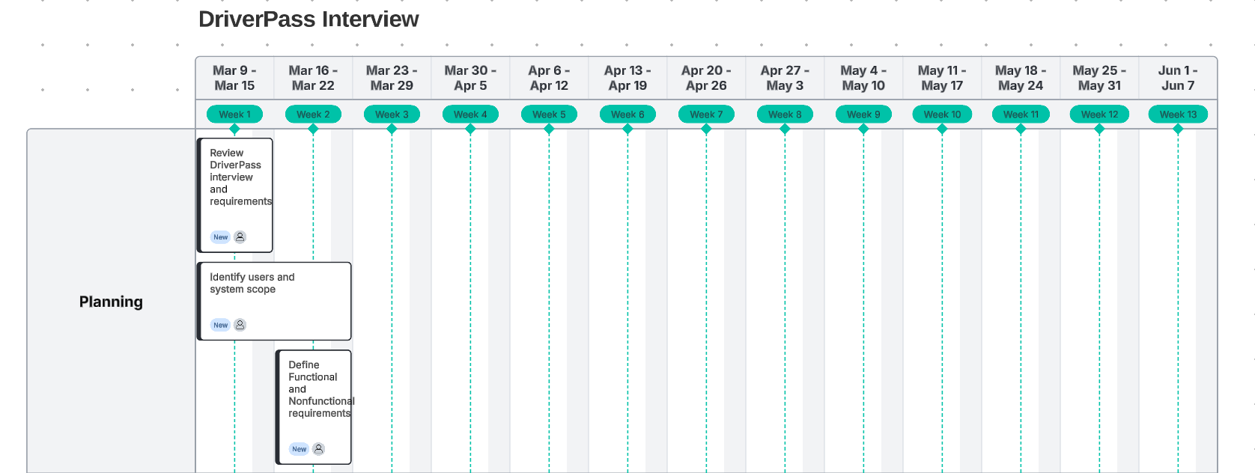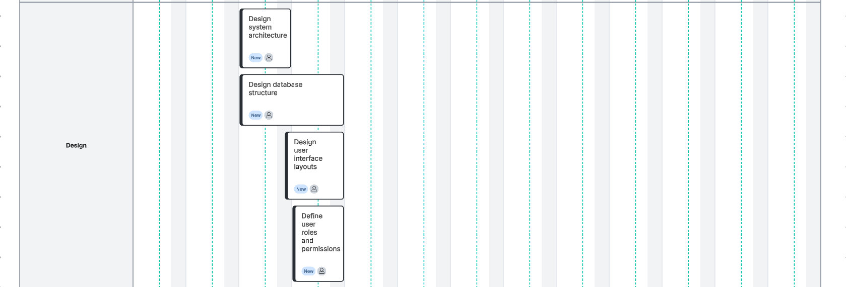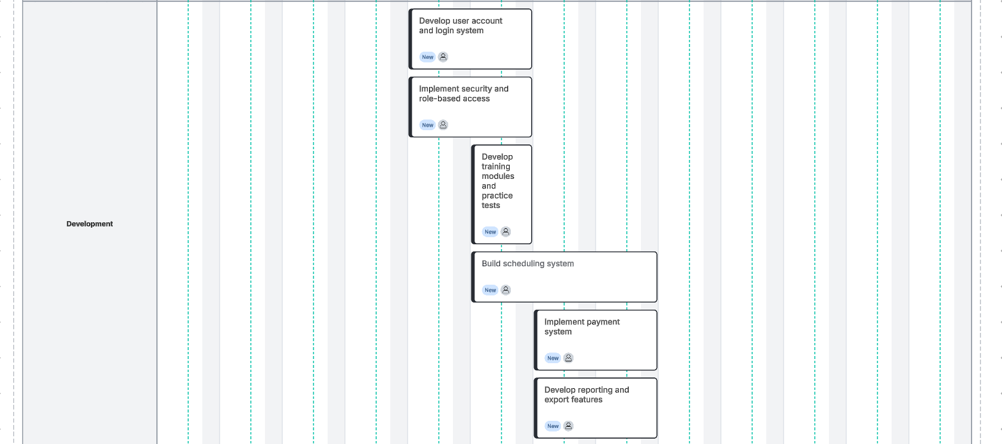
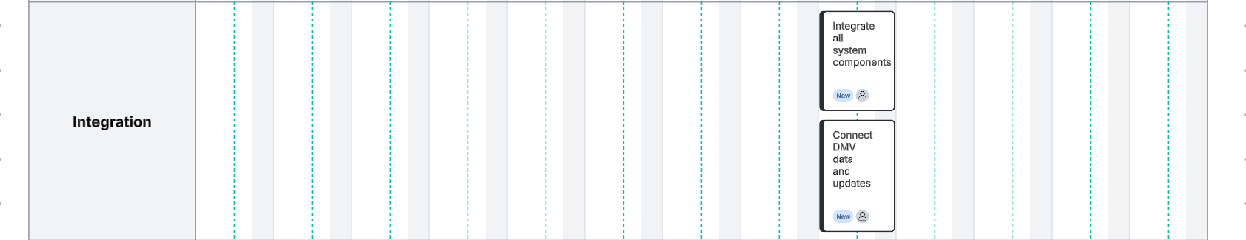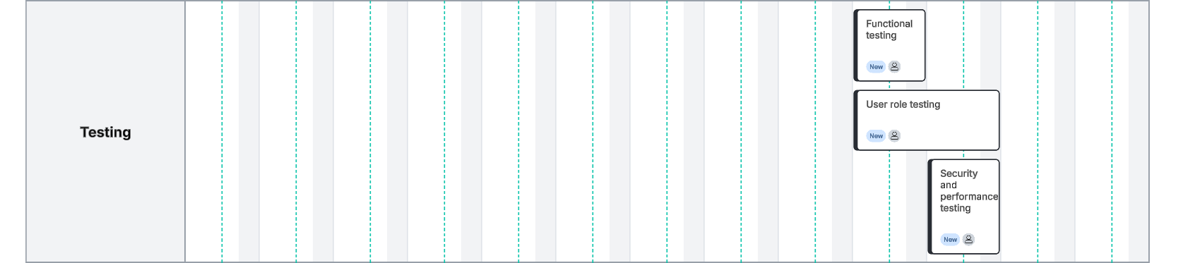
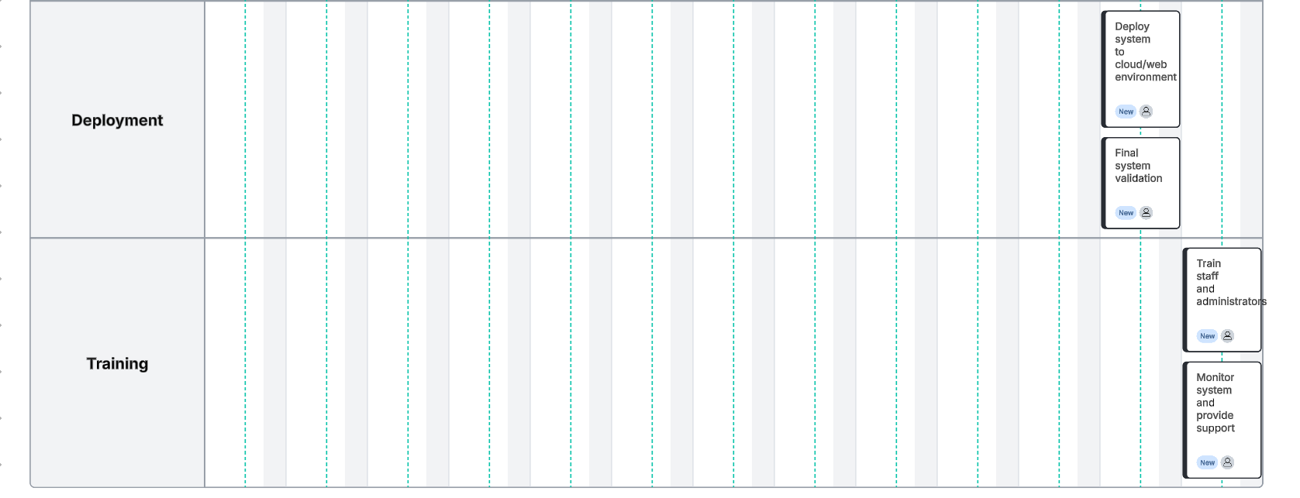

References
Dennis, A., Wixom, B. H., & Tegarden, D. (2012). Systems analysis and design with UML (4th ed.). Wiley.
National Institute of Standards and Technology. (2001). Advanced Encryption Standard (AES). https://nvlpubs.nist.gov/nistpubs/FIPS/NIST.FIPS.197.pdf
Southern New Hampshire University. (n.d.). DriverPass interview transcript [Course material].
Southern New Hampshire University. (n.d.). CS 255 sample business requirements document for an ATM [Course material].

